**Introduction**

According to Geneviève Boisjoly & Genesis T. [Yengoh](https://etrr.springeropen.com/articles/10.1007/s12544-017-0258-4) access to essential services and transportation networks emerges as a pivotal determinant in sheltering decisions, particularly for students, part-time workers, and individuals living independently. Residing within the city limits and in close proximity to educational institutions or workplaces not only reduces commute times but also enhances overall quality of life. This proximity affords individuals more time for relaxation, study, or recreational pursuits while yielding substantial cost savings on transportation expenditures.

In recent years, Cabanatuan City has emerged as a vibrant hub of education, drawing students from diverse backgrounds to its reputable institutions. This year 2024 marks a significant point in this trajectory, as the city witnesses an unprecedented influx of students, all converging with aspirations to further their academic pursuits. Because of this it attracts students from various municipalities and cities of the province who seek to pursue their studies in private and public universities and colleges. However this surge has, precipitated a critical challenge that mirrors the growing pains of a city on the cusp of educational prominence: the scarcity of student accommodations.

As more learners flock to Cabanatuan, the demand for boardinghouses has skyrocketed, leaving many students in a quandary over securing a place to call home during their studies. The quest for affordable, accessible, and conducive living quarters has become a pressing concern, one that underscores the need for a swift and strategic response from both the housing sector and urban planners. Amidst the bustling academic growth of Cabanatuan City, a pressing challenge has emerged: the struggle for students to find suitable boardinghouses. The influx of students has outpaced the availability of accommodations, leading to a dire need for innovative solutions. Enter the Geo-Boarder Application, a cutting-edge platform designed to bridge the gap between students and boardinghouse providers.

A proposed system was developed to address the housing needs of students and other residents of Cabanatuan City-the system aimed to provide a user-friendly interface that offered abundant information on available shelter options. The system was designed to be easy to use, making it accessible to many users. This capacity-building tool stands at the forefront of addressing the accommodation crisis. By leveraging location-based technology, the Geo-Boarder Application empowers students with real-time data and analytics to locate and secure boardinghouses that meet their specific needs and preferences. It is a testament to the power of digital transformation in solving real-world problems that directly affect the student community.

In response to the pressing need for accessible sheltering solutions, the Geo-Boarder application emerges as a beacon of innovation. Leveraging geo-location technology, this user-friendly platform streamlines the search for boarding options tailored to users' preferences and budgets. By integrating geo-location technology, the Geo-Boarder application furnishes users with precise and comprehensive information, revolutionizing the shelter-hunting experience. Originally conceived to address the boarding needs of individuals seeking temporary or permanent accommodation, the Geo-Boarder application transcends its inception to become a versatile cross-platform shelter finder, epitomizing the transformative potential of geo-location technology.

The researchers also considered integrating Google Maps to enhance the Geo-Boarder searching experience. This feature will provide users with more detailed and accurate information on variable shelter options’ locations and surrounding amenities. And it was developed for individuals searching for a place to stay for a few months or years, which proved promising. The study addressed the shelter needs of individual seeking temporary or permanent shelter. The study’s name, Geo-Boarder, had been derived from one of the researchers, and it became a cross-platform shelter finder that leveraged geo-location technology for seamless shelter hunting.

The Geo-Boarder application provides users with an easy-to-use interface that offers abundant information on shelter options. The platform’s geo-location technology allows users to search for properties in their preferred location, making it a convenient and efficient tool for shelter hunting. By integrating geo-location technology, the Geo-Boarder application provided users with accurate and detailed information on available shelter options’ locations and surrounding amenities.

Geo-Boarder catered to various users seeking temporary or permanent shelter options, including students, professionals, and families. The platform provided a comprehensive suite of rooms that formed a complete residence, ensuring users could find suitable shelter options that met their unique needs, preferences, and budget. The study featured pictures and terms of a boarding house to establish a relaxing place that provided safety and comfort to its residents. Its location near Cabanatuan City was an advantage in attracting its target market and providing for their needs. And also aimed to provide excellent service and meet the demands of its target market, offering a comfortable living experience, especially for students from far places, and ensuring safety and security for its residents.

The researchers proposed this type of study as it addressed the current demands and needs of people, particularly those who lived alone, students who lived far from the city, and part-time students or workers. By providing a place to stay within the city and near the places they needed to be, the study made it easier for them to access transportation and travel conveniently, ultimately helping them save money and avoid additional expenses.

Despite the growing demand for shelter finder services in Cabanatuan City due to an increasing number of students and workers relocating from other areas, there needed to be more studies that explored the effectiveness and usability of existing apartment finder systems. Additionally, there needed to be more literature regarding the features and user interface design that were most preferred by the target market, which could inform the development of more user-friendly apartment finder systems. Therefore, further research was needed to identify the key factors that contributed to the success of apartment finder systems in Cabanatuan City and to develop a more effective and user-friendly system that met the needs and preferences of its users.

**Review of Related Literature and Systems**

This section is devoted to the presentation of the literature and research pertaining to the current study. In addition, this section provides a comprehensive discussion of various related systems, thereby facilitating a more profound comprehension of past projects in the same domain.

**Finding a good Apartment**

According to Sahagun ang Flores (2019), there was a growing number of students coming from different distant places, creating a need for the university to have a scheme suitable for the university’s student boarding and residential services. This study was conducted to address the university’s deficiency in providing support to students in terms of boarding services. It aimed to provide apartment locating services that catered to the students needs and connected them to a database that helped the university monitor the current tenancy of the students.

There have been studies on computer applications for finding room/house rentals. The study by Abella et al., (2017) focused on designing and developing an android based mobile application to enable the users to search and locate the closest boarding house in the university belt in Sampaloc, Manila, Philippines. The application makes use of the Global Positioning System (GPS) to get the closest boarding house. Other researchers discussed the development of a mobile application to give information regarding boarding houses. Among other features, the application pushes notifications to users and provides chatting capability (Manalu et al., 2017).

Moreover, in most college towns, there was a shortage of off-campus and students-friendly boarding, forcing students to rent shelter close to the vicinity of the school (Maughan, 2016). This study was Boarding house locator featured the ability to easily monitor the records of each boarding house with permit. It shared some of the an organized database to maintain accurate records and facilitate data retrieval.

**Android-Based Boarding House Management Information System**

According to Nur et al. (2018), due to the high population density in Indonesia, boarding houses played a significant role in minimizing the demand for urban planning space, especially in large cities, as they became the preferred choice for many due to the high cost of buying or renting a shelter. The increasing interest in boarding house created a business opportunity, resulting in substantial profits flowing in every year. Therefore, there was a need to transition from manual methods to a system for effective boarding house management. The system was developed to improve the management of boarding houses, providing an effective solution to existing problems in the industry.

There are applications specifically designed to facilitate the search of accommodation by students in Cabanatuan City that are available internationally. Among them is Places for students, available at places4students.com that allows users to search for accommodation and view the housing details being posted by landlords (Places4Students, n.d). There is a requirement for partnership establishment between application owners and higher education institutions a procedure that may have a financial implication and thus a burden to higher education institutions in Philippines. Therefore, it is unsuitable for the local higher education institutions in our country. Rightmove, available at rightmove.co.uk is another application for searching student accommodation; it allows landlords to post their listings which can be seen by all the users. There is general-purpose renting and student property renting (Rightmove plc, n.d).

**Enhancing Shelter Finding and Geo-Localization Through Visual Analytics and Machine Learning**

In the studies by Di Weng et al. (2018), the researchers addressed the challenging process of finding an ideal shelter. They characterized user requirements and enalytical tasks related to this context and designed a novel visual analytics system to assist users in finding, evaluating, and choosing a shelter based on multiple criteria, including reachability.

Additionally, they developed an improved data-driven model for approximating reachability using massive taxitrajectories. This model allowed user to interactively integrate their knowledge and preferences for making informed decisions. The researchers demonstrated the improvements in their model by comparing theoretical complexities with previous studies and evaluated the usability and effectiveness of their proposed system through task-based evaluations.

According to Ryan(2019), image-based geo-localization is an emerging field of computer vision that has gained significant attention in the past decade. The problem, however, is not straightforward and comes with substantial challenges. In their paper, the researchers presented a novel technique for addressing this problem by combining various machine learning techniques.

They demonstrated the effectiveness of their approach in a particularly challenging city. Specifically, they trained a classifier to isolate building from images, introduced a novel EFM-HOG representation to match the shape of buildings between images, and combined these methods to achieve geo-localization and retrieval results using a dataset created for this purpose.

The application is based in the United Kingdom and only the United Kingdom based properties are listed which creates geographical barriers hence not applicable in our country’s local settings. In Philippines , there are some existing applications that provide information on private rental housing. They include web and mobile applications. Among them is Boards Me App is a mobile application that helps users find nearby boarding houses available in Sampaloc, Manila.that provides information and geographic information concerning house/rooms, hotels, plots, halls, office buildings, and restaurants. The information provided includes price to rent or buying, street, location, landlord contacts as well as satellite view and distance from apartments to other places around that house/room (Rwechungura, n.d.). Also, the application provides search capability and a general description of houses/rooms with pictures. However, the application does not provide filtering capabilities for the search results obtained.

Moreover, it is a general-purpose application, not suited to the students’ accommodation reality hence does not meet students’needs in The Philippines. The application has features such as submitting orders, property owners or brokers are able to respond to customer’s orders, the ability to call broker, house owner or customer instantly (Mixtape, n.d). The user is able to search for brokers, houses or plots by region and street and can filter results. However, a search result filtering is limited to rent fees per month and the number of rooms only. Moreover, it is a general-purpose application, not suited to the students’ accommodation reality hence does not meet students’ needs in Philippines .

There are also application that uses on other country as the same app of board me app it is the Kupatana is another application in Tanzania available at kupatana.com; it is an online and mobile web-based classifieds platform that offers a market place for buyers and sellers to meet (Kupatana AB, n.d). Apart from listing various items for selling, the application has a section for real estate. Among other items listed in this section include houses/apartments/rooms for rent. A user can search by specifying the region and category and then filter the search by using various criteria. The user is also able to send an email to the landlord. With the mobile app, the user can call or send a message to the landlord.

However, the application does not show the geographical location of the house/apartment/room for rent on a map. Also, the application does not provide house sharing or roommate finding options. Moreover, it is a general-purpose application, not suited to the students’ accommodation reality hence does not meet students’ needs in Philippines including Manila area.

Currently, in Philippines there is no application dedicated to serving the needs of students regarding private rental accommodation, the existing applications are general-purpose applications that do not meet students’ requirements as they search for private rental accommodation. Therefore, this study proposes the development of an online portal that will provide a link between prospective student tenants and private rental accommodation service providers and will act as a central source of information regarding private rental students’ accommodation described in terms of the geographical setting of Philippines, and according to the needs of students in Cabanatuan City Philippines , hence making room/house finding an easy process to students.

**Synthesis**

The system was developed based on local and foreign studies, which served as the foundation for this project. It also encompassed a detailed description of the system's available features. All the systems related to this study had similarities, but issues related to bookings and security were observed in these systems.

The systems discussed were linked to the researchers' system, "Home-Finder in Cabanatuan City." The researchers conducted a thorough analysis and evaluation of these related systems, taking into consideration their modules and functions. During the evaluation, the researchers identified certain functions and factors from the related systems that could enhance the system, making it more advanced, accurate, and effective for users. Additionally, the researchers incorporated some features from the related studies into their system to make it more beneficial for hotel companies

**Conceptual Framework**

Figure 1 shows the research paradigm for this study. The framework served as a guide for the conduct of the activities necessary for this study.

Figure 1

Research Paradigm

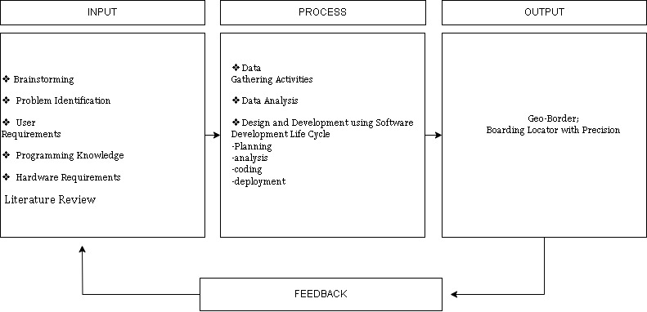

The research paradigm for this study included four significant elements: Input, Process, Output, and Feedback.

The "**Input**" box contained activities such as brainstorming, problem identification, user requirements analysis, selecting appropriate programming languages, determining hardware requirements, and 20 reviewing related literature and studies. These activities were essential for gathering crucial data and inputs for the system's development. After successfully executing the activities in the "Input" box, the "Process" box followed.

The "**Process**" box involved activities such as data gathering, data analysis, and the actual design and development of the system, following the phases of the Software Development Life Cycle. These activities were necessary to carry out the development procedures and actions required for the study.

The "**Output**" box contained the actual Home-Finder application after completing the project's development. IT experts and endusers, who served as respondents for this study, assessed the developed system. Their comments and suggestions were considered for future refinements, and thus, the "Feedback" element was included to address additional changes and improvements to the system.

The activities outlined in the IPO framework were crucial for the project's development and were diligently followed and 12 executed by the researchers to ensure the study's systematic conduct.

**Statements of the Problem**

The study aimed to design, develop, and assess an application called "Geo-Boarder”:. It is a Cross-Platform Apartment Finder using Geo-location Technology for Seamless House Hunting in Cabanatuan City.

Specifically, it sought to answer the following:

1. **How may the manual system be described based on the following:**
2. Security of Files and Records;
3. Management of Data;
4. Reliability of Output;
5. Efficiency of Processes; and
6. Compliance with Regulations and Standards?
7. **How may the design and development of the system be described in terms of the phases of the Software Development Life Cycle which include:**
8. Requirements Analysis;
9. Design;
10. Development;
11. Testing;
12. Deployment; and
13. Maintenance?
14. **How may the system be assessed by IT Experts in terms of its technical characteristics using the ISO 25010 Standard which comprises of:**
15. Functional Suitability;
16. Performance Efficiency;
17. Compatibility;
18. Usability;
19. Reliability;
20. Security;
21. Maintainability; and
22. Portability?
23. **How may the system be assessed by end users in terms of its Quality of Use using the selected ISO 25010 Standard which includes:**
24. Functional Suitability;
25. Usability and
26. Performance Efficiency?

**Scope and Delimitations**

The study focused on developing a Geo-Boarder system also known as "Boarding Locator with Precision". The system required gadgets such as smart phones and tablets to install and run the application. The application was downloadable and usable with an internet connection. After using the application, users could rate the system on a scale of 1 to 4.

The Geo-Boarder system is intended to find and display all relevant details about apartments, and the system is only available in Cabanatuan City. The researchers planned to assess the technical aspects of the system using ISO 25010 standards and gathered feedback from IT experts and end-users. The study aims to provide a useful and efficient tool for those looking for apartments in Cabanatuan City.

**Significance of the Study**

This study will be beneficial to the following:

Tenants the proposed system will provide a more convenient and faster way for tenants to book rooms and access information about them, including their location, prices, 15 availability, and amenities. The system will streamline the entire process, allowing tenants to search and view available rooms, make reservations, and receive confirmation with just a few clicks. In addition, the system will also enable tenants to make online payments and communicate with the landlords or property managers through a messaging feature within the application. This will make the rental process smoother and more efficient for tenants and landlords.

Boarding House Owner the system will benefit the owner by promoting and improving their business through online platforms.

Researchers the conduct of this study will benefit the researchers because, through this academic endeavor, their skills in the field of information technology will be enhanced. This includes application development and technical writing skills.

Future Researchers the results of this study will benefit the future researchers with interests related to the design, development and assessment of boarding house integrating geo-location technology.

**Definition of Terms**

The researchers gathered these terminologies for a better and more precise understanding of the study.

Administrator an administrator is an individual or entity responsible for overseeing and managing various aspects of an organization, system, or environment. Administrators typically hold authority and decision-making power to ensure that operations run smoothly and efficiently. Their roles and responsibilities may vary widely depending on the context, but they often involve tasks such as planning, organizing, coordinating, monitoring, and making decisions to achieve specific objectives. In the context of computer systems or networks, an administrator is responsible for managing and maintaining the system's functionality, user accounts, security, and configurations. Administrators may also be referred to as managers, supervisors, or system administrators, depending on their specific roles and domains.

Android refers to a popular mobile operating system (OS) that was developed by Google. It is designed primarily for touch screen mobile devices, such as smart phones and tablets. Android is based on a modified version of the Linux kernel and offers an open-source platform for developers to create applications and software that can run on a wide range of devices.

Boarding House a boarding house is a type of residential accommodation where individuals rent rooms or living spaces within a larger, shared building. Boarding houses offer lodging for people, typically on a short- to medium-term basis, and often provide a communal living environment.

Database A database is a structured collection of data that is organized and stored electronically in a way that allows for efficient retrieval, management, and manipulation of the data. Databases are designed to store, manage, and provide access to vast amounts of information, making them a crucial component in various computer systems and applications.

Google Map Google Maps is a web-based mapping service and application developed by 18 Google. It provides a wide range of geographical and location-based information, including maps, directions, satellite imagery, street views, and more. Google Maps is accessible through web browsers on computers and as a mobile app on smart phones and tablets.

**Chapter II**

**METHODOLOGY**

This section introduces the research design, geographical location and participants, the tool, the methods of collecting data and techniques for data analysis, and ethical factors in the investigation.

**Research Design**

Developmental research refers to a methodical methodology employed in the examination of numerical information, encompassing the measurement or enumeration of characteristics (Hartmann, D. P., Pelzel, K. E., & Abbott, C. B. (2011) ) This technique aims to quantify inclinations, viewpoints, actions, and other explicitly defined variables, while also extrapolating findings from a broader sample populace through the generation of numerical data.

For this study, the researchers specifically employed a descriptive developmental approach to describe the activities undertaken by the researchers for the design and development of the system, as 100 well as to describe the assessment made by the respondents to the developed system.

**Locale of the Study**

The study was conducted at Cabanatuan City. Figure 2 shows the location map of Cabanatuan City.

Figure 2

Location Map of Cabanatuan City, Nueva Ecija.

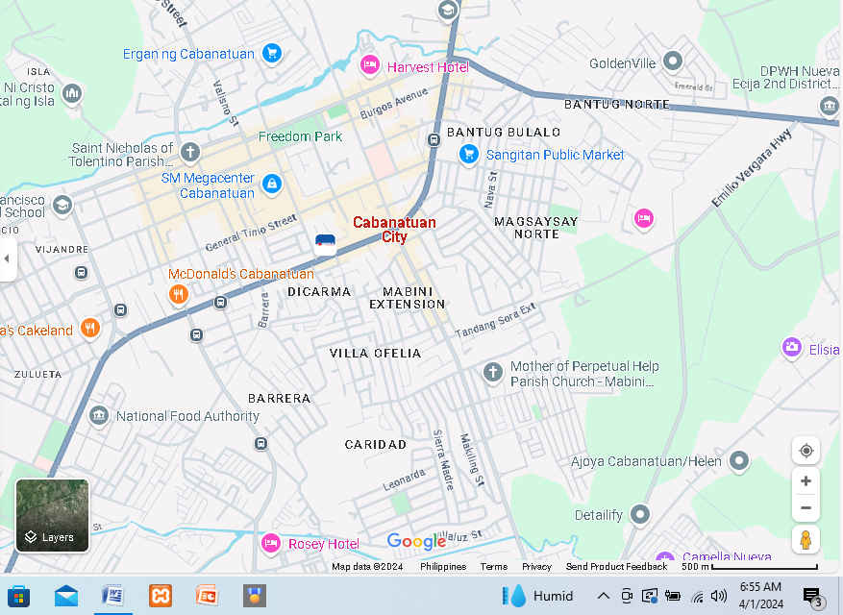

The chosen locale was suitable for the study as it aligned with the primary concern, which revolved around the challenges students encountered when searching for temporary accommodation while pursuing their education in the city. More specifically, the study 21 zeroed in on individuals who hailed from other municipalities within the province, rendering the selected locale highly pertinent to the research.

**Respondents**

There were two groups of respondents in the study and both were chosen using purposive sampling. The first group was composed of one (3) IT experts and the second group was composed of one hundred (100) end-users.

The focus of the IT experts was to evaluate the technical characteristics of the Web-based application according to the ISO 25010 Software Product Quality Standards on functional suitability, performance efficiency, compatibility, usability, reliability, security, maintainability, and portability as well as the level of effectiveness of the implementation of the developed system.

Table 1

Distribution of Respondents

|  |  |
| --- | --- |
| Respondents | Number of Respondents |
| IT Experts | 3 |
| End user | 100 |
|  |  |
|  |  |
|  |  |
|  |  |
| Total | 103 |

Table 1 shows the distribution of the respondents. The respondents consist of 100 end-users who are from the students of Cabanatuan City and 3 IT experts from the University and selected offices and institutions in the province of Nueva Ecija.

**Sample Procedure**

For some studies, the population may be small enough to warrant the inclusion of all of them in the study. But a study may entail a large population which cannot all be studied. That portion of the population that is studied is called a sample of the population (Nworgu 1991:69). A sample in this study is, therefore, a smaller group. of elements drawn through a definite procedure from an accessible population. The elements making up this sample are those that are actually studied. The sample of the population of this study stood at 100 end users and 3 IT experts gave a total of 103 respondents.

**Sampling Techniques**

A stratified random sampling procedure was used for selecting the participants in this study. This technique was employed to ensure a fairly equal representation of the variables for the study. The stratification was based on state government and private owned Collage Students in Cabanatuan City Nueva Ecija. Within each School, selection of students was by simple random sampling. This was achieved by writing out the names of the staff in piece of paper which was folded and put in a basket. After thorough reshuffling, the researcher selects an element, records it and puts it back in the basket until the required number is obtained. That is, researcher applied sampling with replacement. Proportionate stratified random sampling technique was employed to select 100 Students and 3 IT experts from Neust university in Cabanatuan City.

**Research Instruments**

The researcher designed an interview schedule as one of the data collection instrument for this study. The Collage students were interviewed. The interview questions were aimed at eliciting relevant information concerning the benefit of Geo-Boarder system in Cabanatuan. Questions relating to Geo-Boarder system, perceived the benefits and instruction of using this technology in seeking of Boarding House near the school or universities they wanted to be.

A questionnaire designed by the researcher titled ”Geo Border: Student Boarding Locator ” was also used in the study. The content of the instrument was based on the findings of the interview conducted of the IT students of Nueva Ecija University of Science and Technology (NEUST).